The most frequent change that will need to be made in to update the hourly rates on the casual payment submission spreadsheet. However, there may be other changes required to the conditions or calculations.
Contents

1. Editing the spreadsheet 1
2. Troubleshooting 4
2.1. The correct list of values is not appearing when viewing the list of values in the Rate of Pay field 4
2.2. The warning message does not appear when an hourly rate below the lower limit is entered 5

Knowledge Article: Casual Payment Submission Spreadsheet Knowledge Article_V3.0.docx

Editing the spreadsheet

12. Support\Payroll\Casual payment submission spreadsheet

NB: Whenever any changes are made to the spreadsheet the header must be updated. See steps 13 and 14

- Open the current version of the spreadsheet, save a copy with the next version number in the file name.

- Before you can make any changes you need to unprotect the workbook:

File > Info > Protect Workbook and choose 'Protect Workbook Structure'.

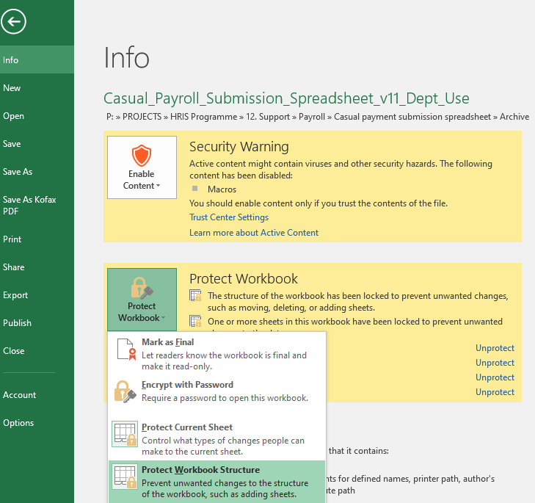

- Enter the current password (found in the Technical Specification document) | 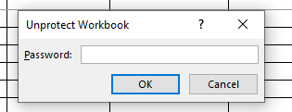

- Right click on any of the tabs and Unhide the Hourly Rates sheet.

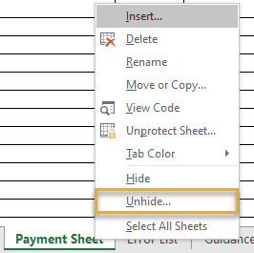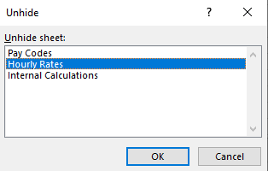

- Delete the existing hourly rate details.

- Paste in the new list of spinal points and hourly rates, ensuring that the list appears in value order, lowest value at the top.

 | NB: The rate is the only value that is required, however the Spinal Point is included for reference purposes.

- In cell E2 – 'Error below hourly rate': enter the new lowest hourly rate. (This is linked to the warning messages on the input sheet.) | 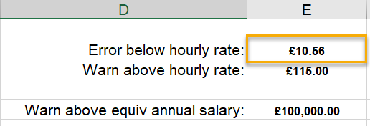

- On the Payment Sheet click in the Rate of Pay column and view the list of values – check that the new list of values is appearing in full. If it is not appearing as expected, check the HourlyRateList. See section 2.1 for guidance.

- Enter a line of data and check that the data is populated correctly on the Payroll Use Only tab.

- On the same line, enter a rate of pay that is less than the lowest value on the list. The field should be highlighted in Red and the Error list tab includes the message 'Rate of Pay is below lower limit'.

- Once all edits are completed hide the Hourly Rates sheet.

- On the Payment Sheet right click on the tab, choose 'Unprotect Sheet' and enter the relevant password (should be the same as the one to unprotect the workbook). | 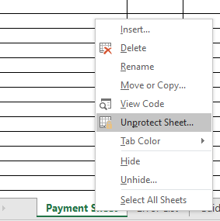

- In the header row change the 'Valid from' date and update the note at the end.

- Change the colour. (Refer to the spreadsheet tracker and choose a colour that hasn't been used recently.)

 | NB: The colour enables payroll to see at a glance whether the correct version of the spreadsheet is being used.

- Once you have made all the changes, place the cursor in cell A5. (This ensures that users start at the right point on the sheet.)

- Protect the workbook structure following the same steps to unprotect it.
NB: You will need to enter the password twice.

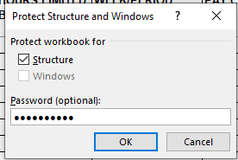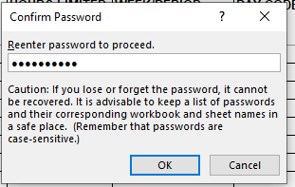

Troubleshooting

The correct list of values is not appearing when viewing the list of values in the Rate of Pay field

- Check that the HourlyRateList refers to a single column of data that contains all of the hourly rates in the list (excluding the column header).

Go to Formulas > Name Manager | 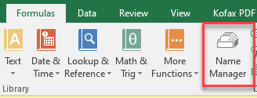

- Locate the formula called HourlyRateList and check that the range shown covers the full list of rates (excluding the header row).

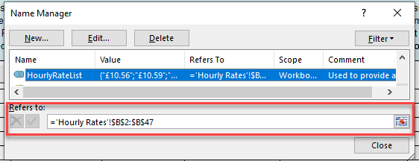

- Edit if required.

The warning message does not appear when an hourly rate below the lower limit is entered

Refer to the Technical Specification document. This covers a number of different scenarios.

